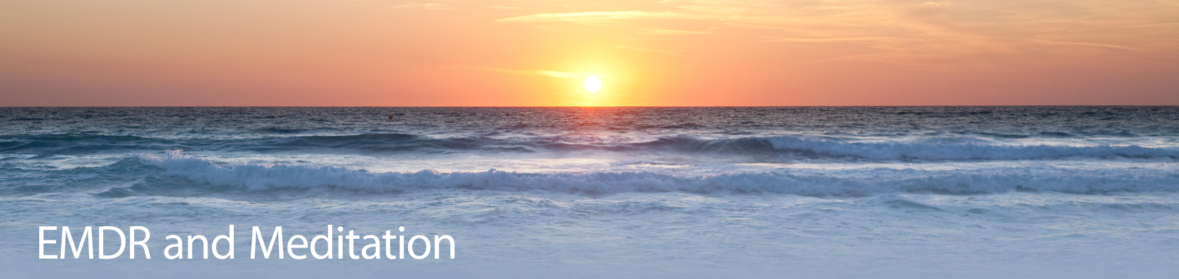

Registration Form

(Please Print)

Name of Workshop: _____________________________________

Date(s): _____________________________________________

Your Name: __________________________________________

Profession: ________________________ Degree: ____________

License/Registration Number ______________________________

Bus. Address: _________________________________________

City/State/Zip: _______________________________________

Work Number: ________________________________________

e-mail: ______________________________________________

How did you find out about us? ________________________________

Please make check payable and send to:

William M. Zangwill, Ph.D.
EMDRIA Approved Trainer
124 W. 93rd St. #9F
NY, NY 10025

For additional information, please contact me at the address above,
by email William@DrZangwill.com or by phone (212) 663-2989.

